A lightweight API that route AI requests, based on real time grid usage and hardware availability. Instead of sending every request to heavy cloud service, we route the to a effecient hardware or schedule when at the peak of the renewable energy supplys

Metrics and goals
- Cost reduction
- Provide usage on resources constrainted device
- Prediction of real time or (t+1) grid power
- Definition of re-routing/ load balancing (priorities vs availability)
Linear optimisation
Re routing schedule

What current ATS system are:

What are the features?

If you cant find solution to solve bias, at least identify it

what solution is, how to come to this solution, why is this solution and whats next

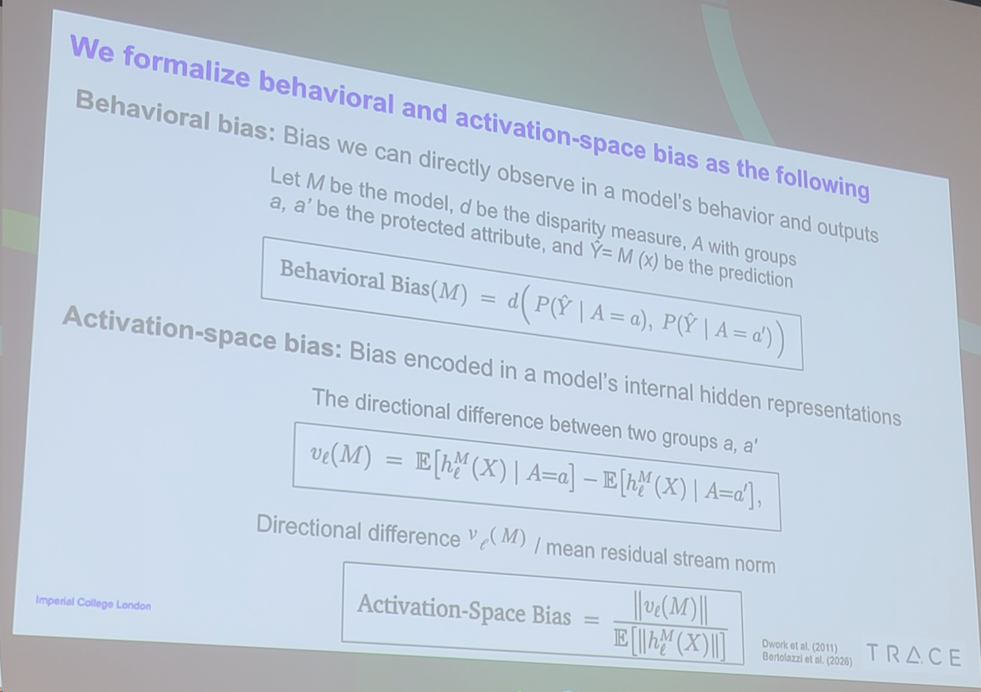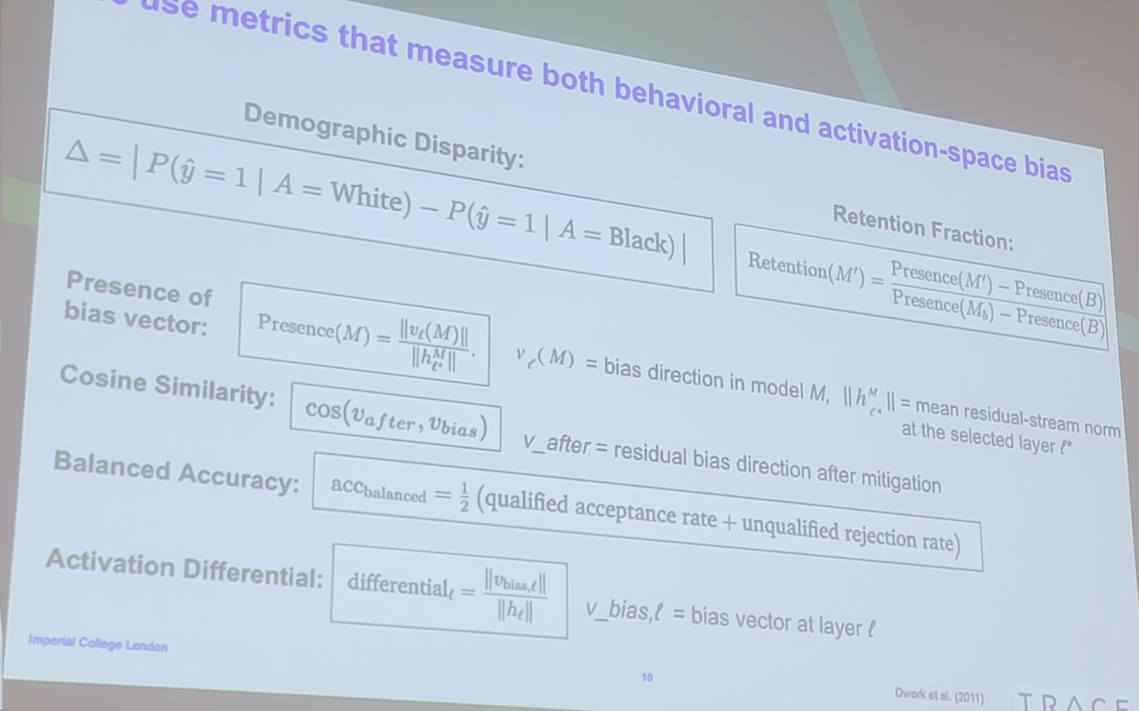what your thing actually do, what my life easier not harder

health care digital twin